Lab plan No.4 Name: Muhammad Faizan Reg. No. 21-NTU-CS-1258

# Question No.1

## Input:

#include<iostream>

using namespace std;

int main()

{

int num;

cout<<"Enter your marks in Programming Course: ";

cin>>num;

(num>=60)? cout<<"\nHe is Passed in the course" : cout<<"\nHe is Failed";

return 0;

}

## Output:

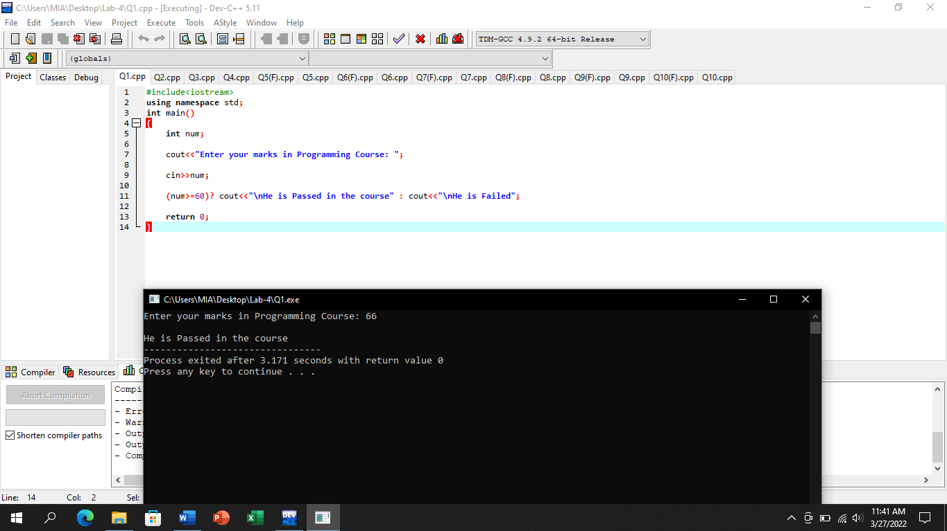

# Question No.2

## Input:

#include<iostream>

using namespace std;

int main()

{

int num;

cout<<"Enter a Digit: ";

cin>>num;

(num%2==0) ? cout<<"\nThe given Digit is even" : cout<<"\nThe given Digit is odd";

return 0;

}

## Output:

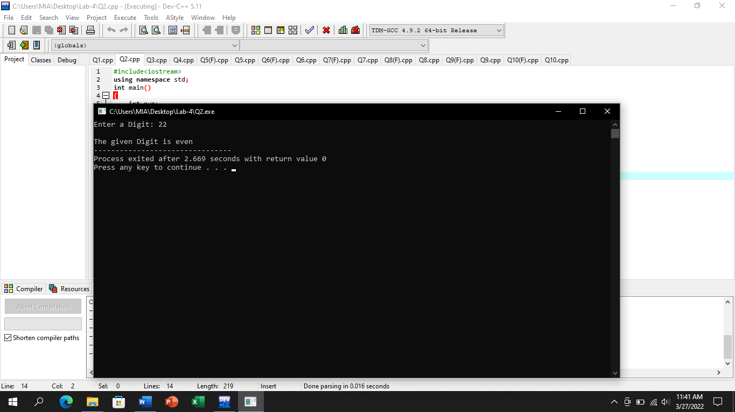

# Question No.3

## Input:

#include<iostream>

using namespace std;

int main()

{

int num_1,num_2;

cout<<"Enter first integer: ";

cin>>num_1;

cout<<"\nEnter second integer: ";

cin>>num_2;

(num_1%num_2==0) ? cout<<"/nThe first integer is multiple of second integer" : cout<<"\nThe first integer is not multiple of second integer";

return 0;

}

## Output:

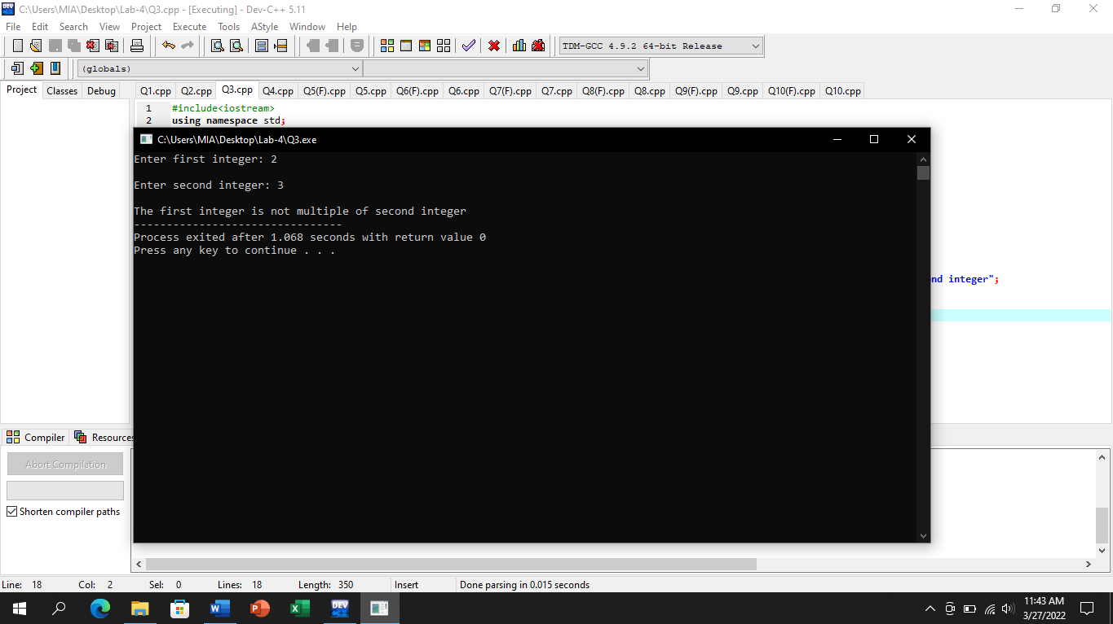

# Question No.4

## Input:

#include<iostream>

using namespace std;

int main()

{

int pay,age;

char gender;

cout<<"Enter your Gender(M for male, F for female): ";

cin>>gender;

cout<<"\nEnter your Age: ";

cin>>age;

cout<<"\nEnter your Salary: ";

cin>>pay;

if((gender=='M'||gender=='F')&&(age>40)&&(pay>30000))

{

//bonus is 20%

cout<<"/nYour bonus is: "<<(20*pay)/100<<endl;

}

else if((gender=='M')&&(age<40)&&(pay>20000))

{

//bonus is 15%

cout<<"\nYour bonus is: "<<(15*pay)/100<<endl;

}

else if((gender=='F')&&(age<30)&&(pay>20000))

{

//bonus is 10%

cout<<"\nYour bonus is: "<<(10*pay)/100<<endl;

}

else

{

cout<<"\nYou are not eligible for bonus";

}

return 0;

}

## Output:

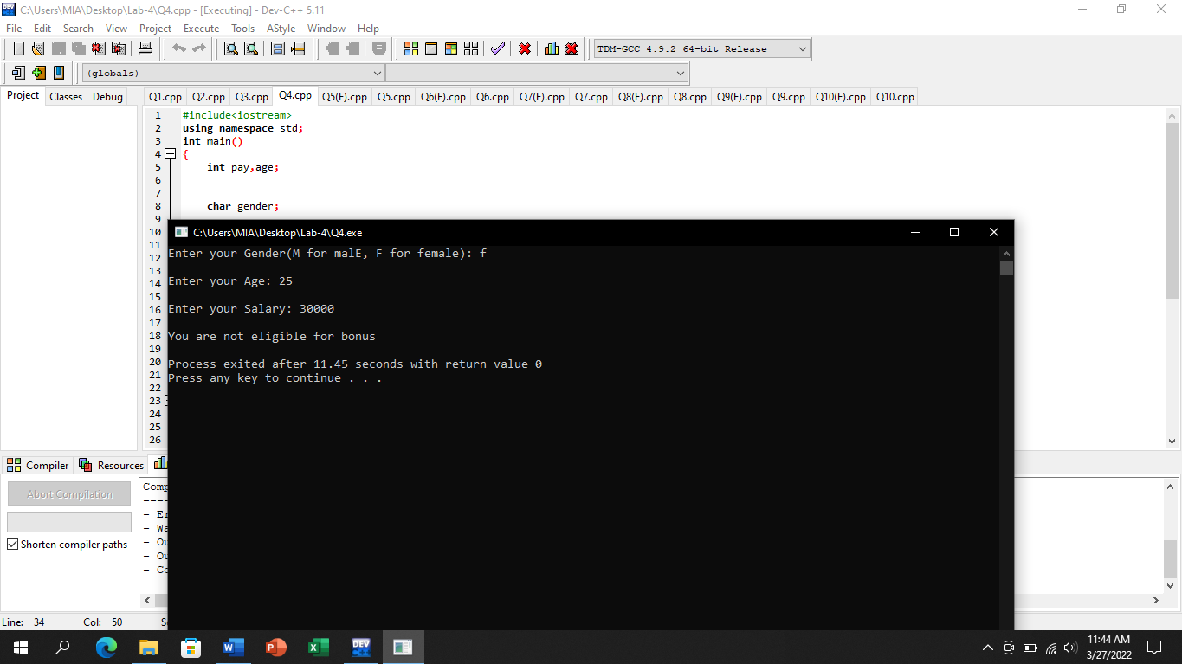

# Question No.5

## Input:

#include<iostream>

using namespace std;

int main()

{

int i;

i=1;

while(i<=100)

{

cout<<i;

cout<<"\t";

i++;

}

return 0;

}

## Output:

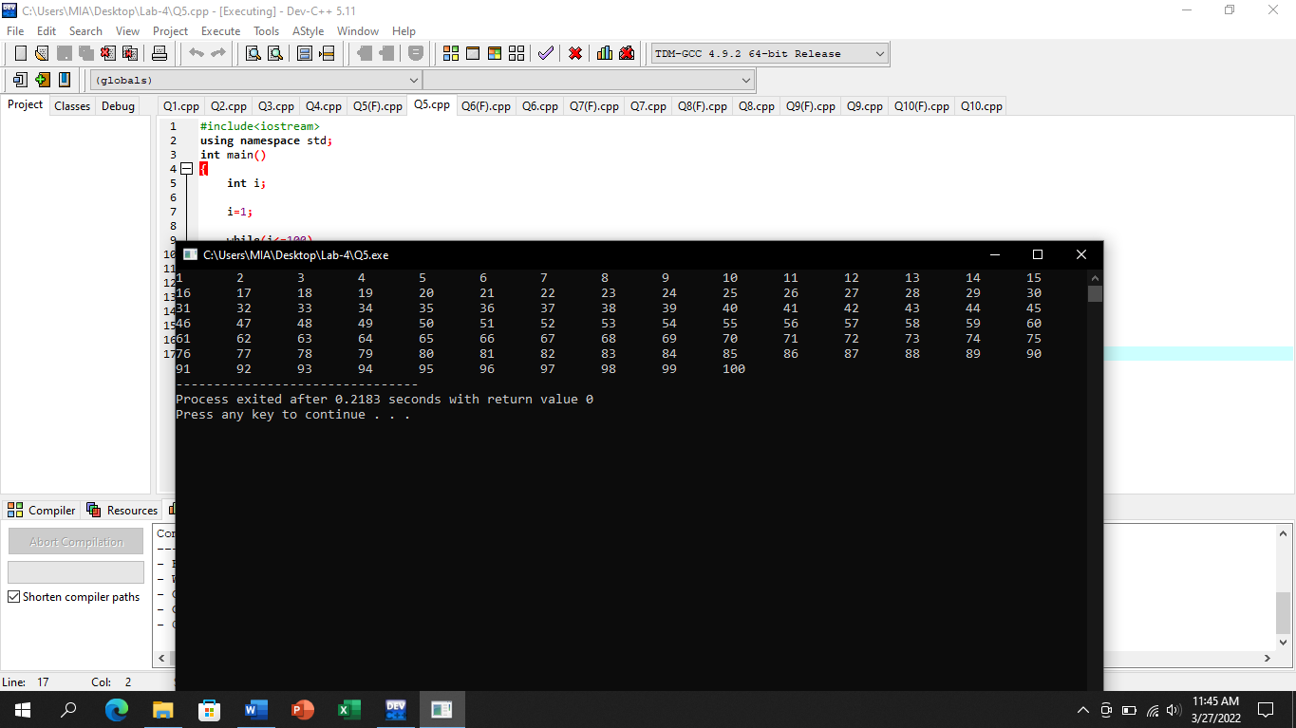

# (With for statement)

## Input:

#include<iostream>

using namespace std;

int main()

{

for(int i=1;i<=100;i++)

{

cout<<i<<"\t";

}

return 0;

}

## Output:

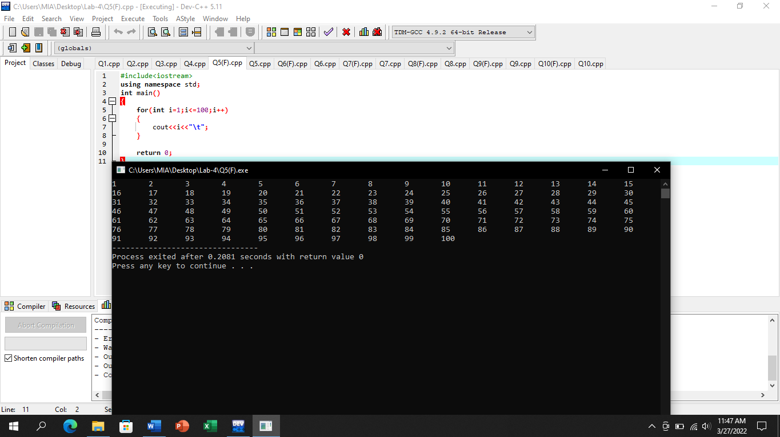

# Question No.6

## Input:

#include<iostream>

using namespace std;

int main()

{

int i;

i=100;

while(i>=1)

{

cout<<i;

cout<<"\n";

i--;

}

return 0;

}

## Output:

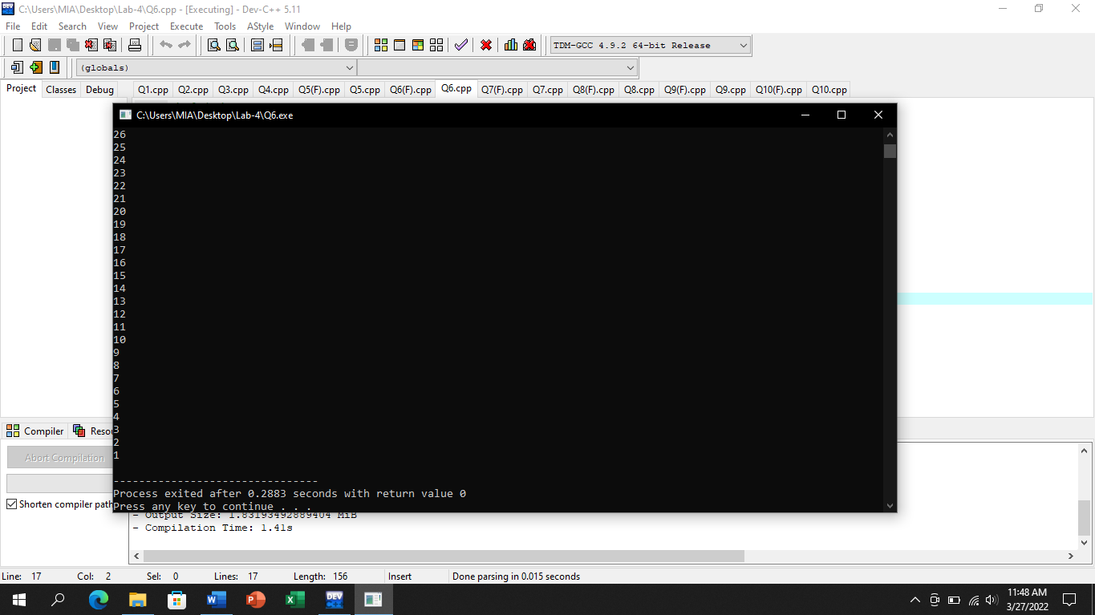

# (With for statement)

## Input:

#include<iostream>

using namespace std;

int main()

{

for(int i=100;i>=1;i--)

{

cout<<i<<"\n";

}

return 0;

}

## Output:

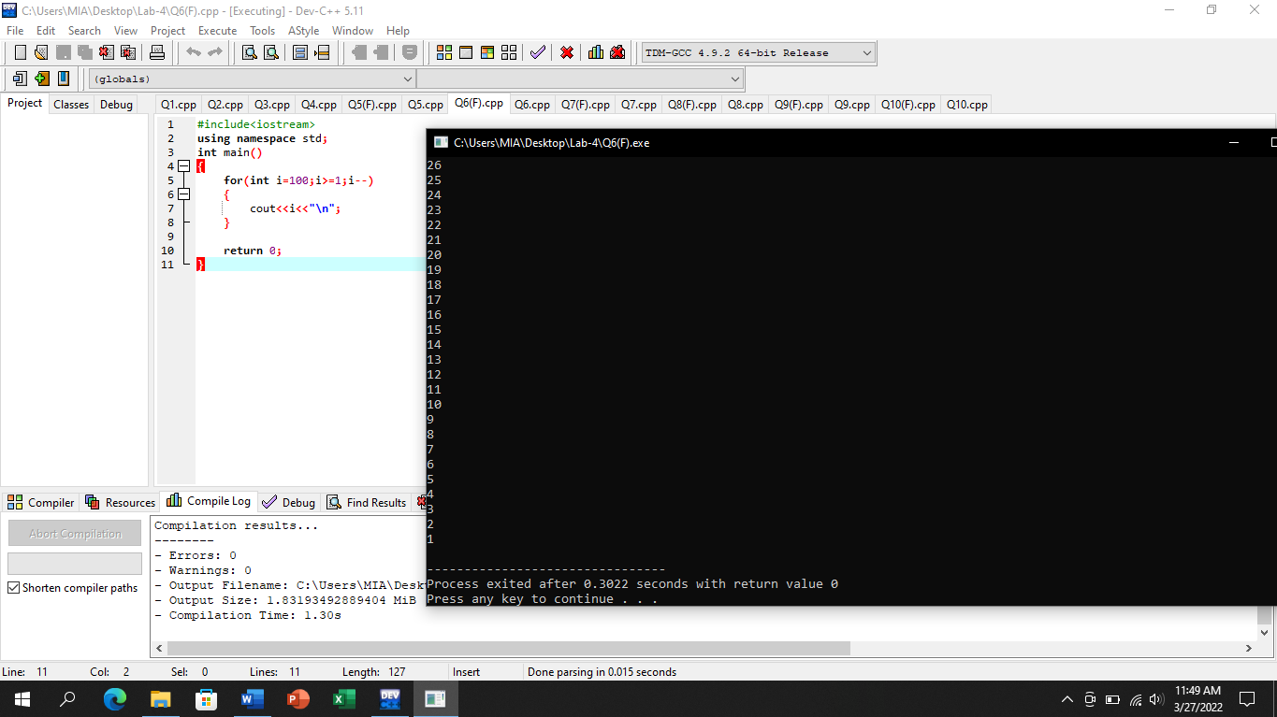

# Question No.7

## Input:

#include<iostream>

using namespace std;

int main()

{

int num,i;

cout<<"Enter a number: ";

cin>>num;

i=0;

while(i<=num)

{

cout<<i;

cout<<"\t";

i++;

}

return 0;

}

## Output:

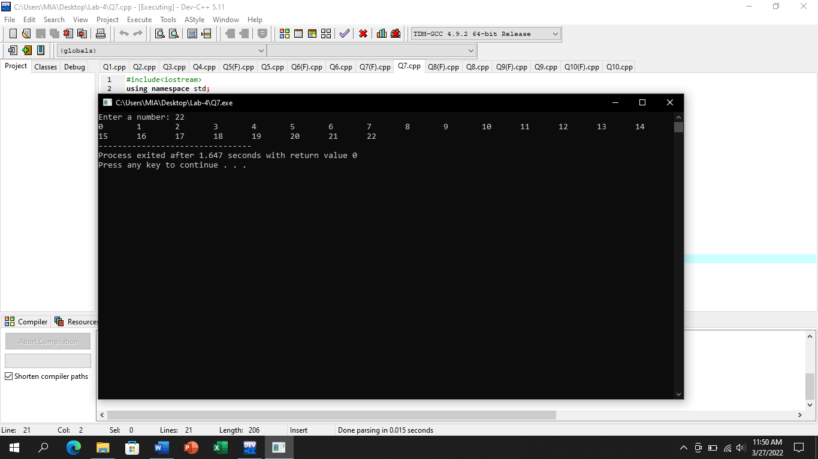

# (With for statement)

## Input:

#include<iostream>

using namespace std;

int main()

{

int num;

cout<<"Enter a number: ";

cin>>num;

for(int i=0;i<=num;i++)

{

cout<<i<<"\t";

}

return 0;

}

## Output:

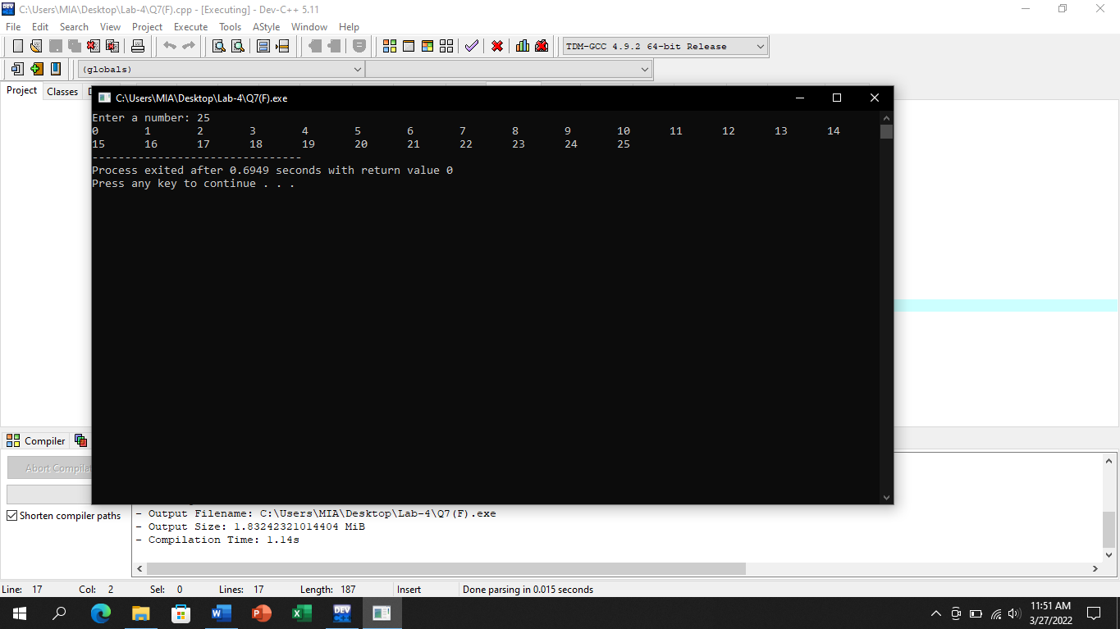

# Question No.8

## Input:

#include<iostream>

using namespace std;

int main()

{

int i;

//For even numbers

i=1;

while(i<=100)

{

if(i%2==0)

cout<<i;

cout<<"\n";

i++;

}

cout<<"\n";

//for odd numbers

i=1;

while(i<=100)

{

if(i%2!=0)

cout<<i;

cout<<" ";

i++;

}

return 0;

}

## Output:

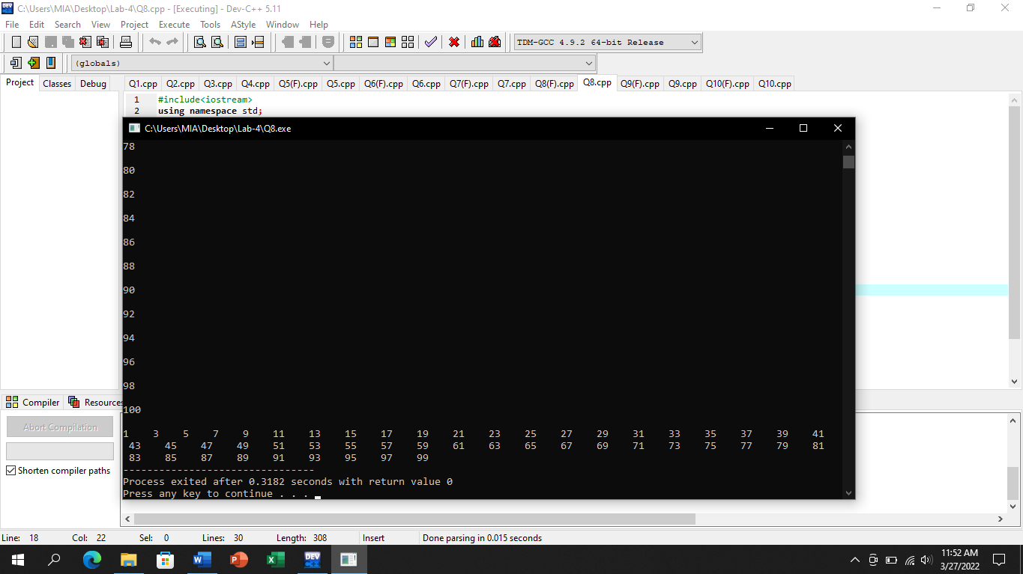

# (With for statement)

## Input:

#include<iostream>

using namespace std;

int main()

{

//For even numbers

for(int i=1;i<=100;i++)

{

if(i%2==0)

cout<<i<<"\n";

}

cout<<"\n";

//for odd numbers

for(int i=1;i<=100;i++)

{

if(i%2!=0)

cout<<i;

cout<<" ";

}

return 0;

}

## Output:

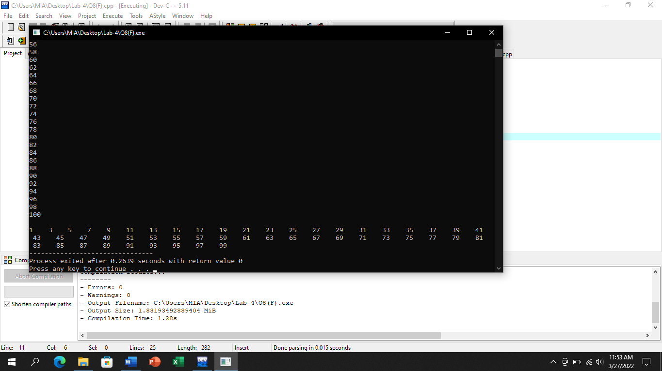

# Question No.9

## Input:

#include<iostream>

using namespace std;

int main()

{

int i,add;

add=0;

i=1;

while(i<=25)

{

add=add+i;

i++;

}

cout<<"Average is: "<<add/25;

return 0;

}

## Output:

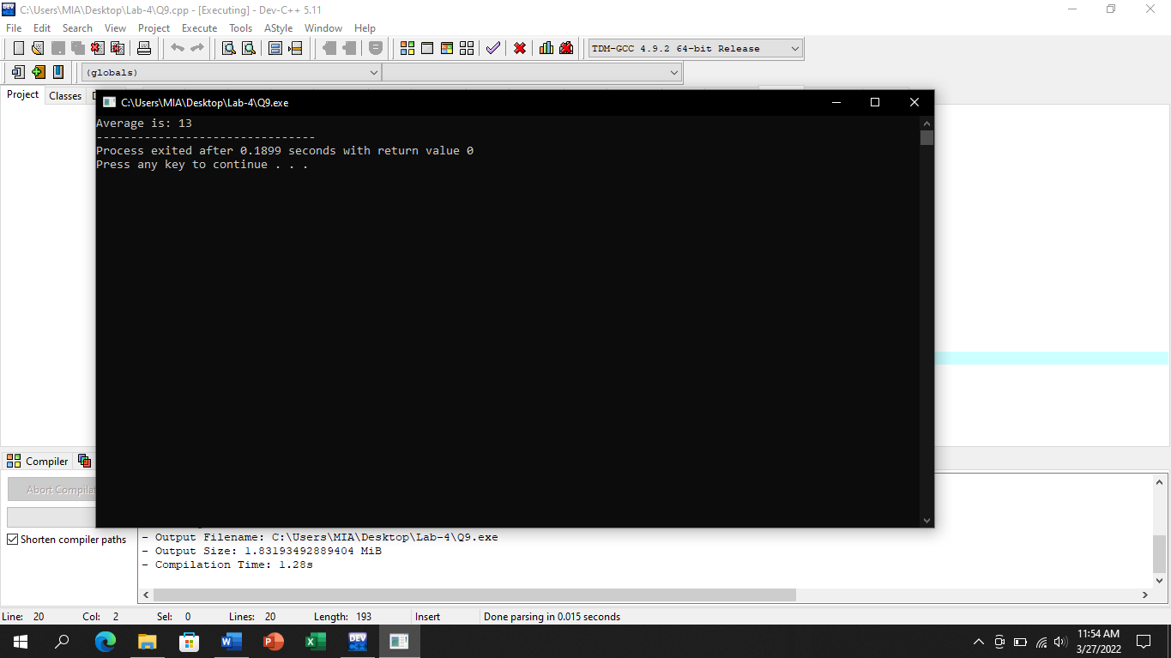

# (With for statement)

## Input:

#include<iostream>

using namespace std;

int main()

{

int i,add;

for(i=1,add=0;i<=25;i++)

{

add=add+i;

}

cout<<"Average is: "<<(add)/25;

return 0;

}

## Output:

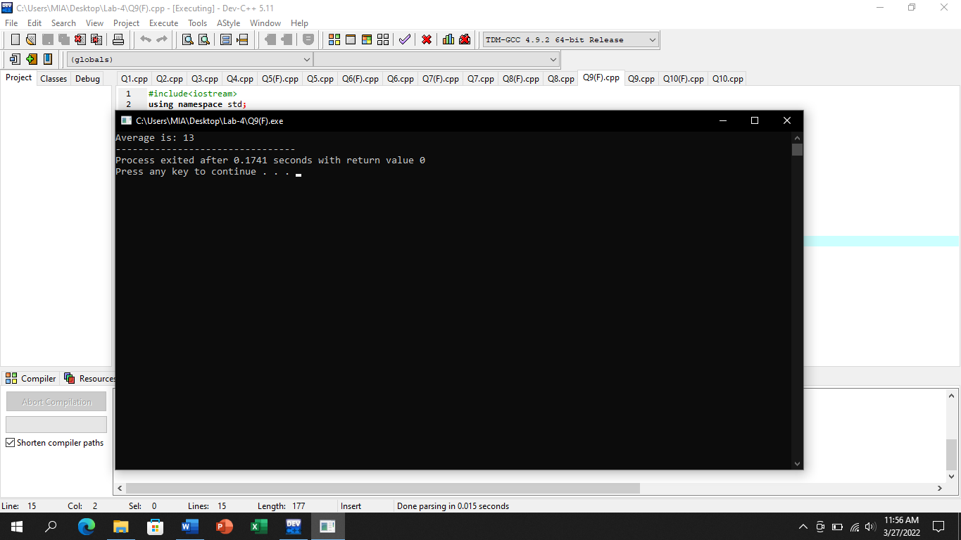

# Question No.10

## Input:

#include<iostream>

using namespace std;

int main()

{

int i,marks,sum;

sum=0;

i=1;

while(i<=10)

{

cout<<"Enter marks of student: ";

cin>>marks;

sum=sum+marks;

i++;

}

cout<<"Average is: "<<sum/10;

return 0;

}

## Output:

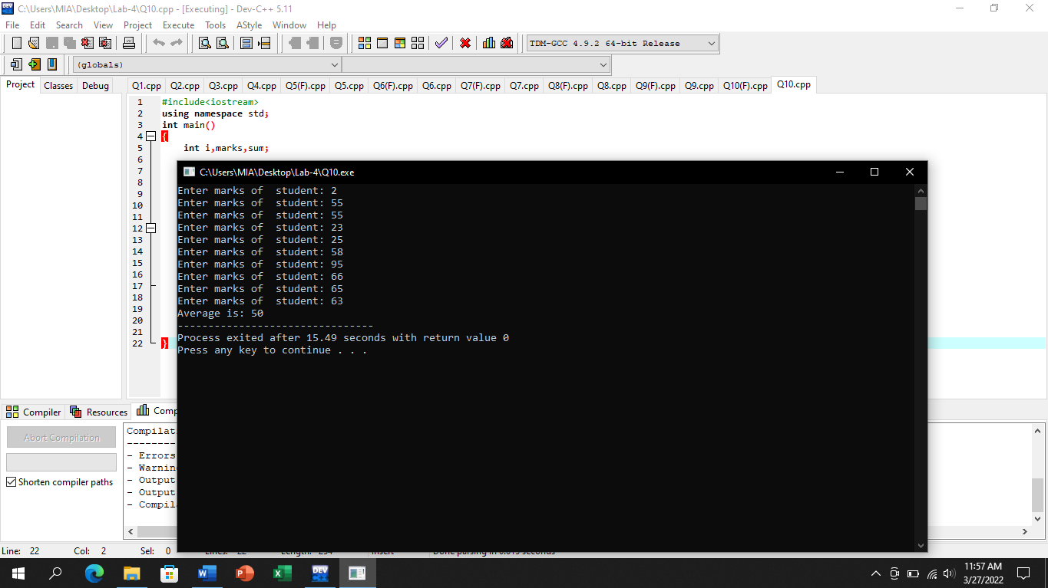

# (With for statement)

## Input:

#include<iostream>

using namespace std;

int main()

{

int i,marks,sum;

for(i=1,sum=0;i<=10;i++)

{

cout<<"Enter marks of student: ";

cin>>marks;

sum=sum+marks;

}

cout<<"Average is: "<<sum/10;

return 0;

}

## Output:

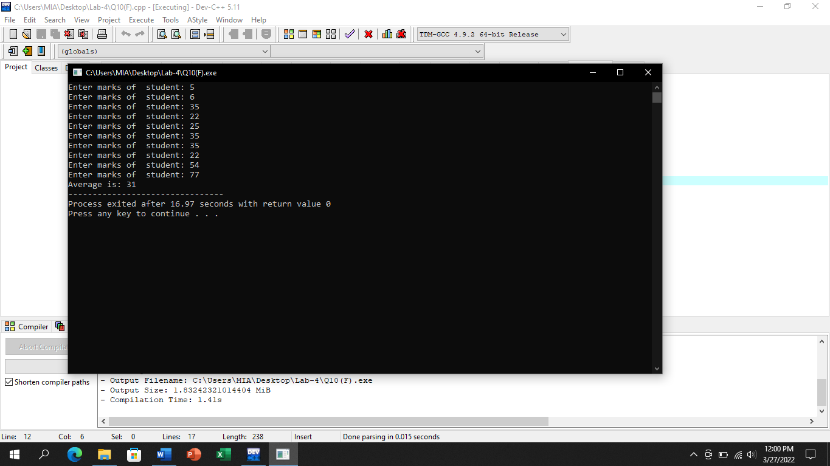

# Question No.11

## Input:

#include<iostream>

using namespace std;

int main()

{

int i,male,female;

char gender;

male=0;

female=0;

i=1;

while(i<=10)

{

cout<<"Enter Your gender: ";

cin>>gender;

if(gender=='M'||gender=='m')

male++;

if(gender=='F'||gender=='f')

female++;

i++;

}

cout<<"No. of males: "<<male<<endl;

cout<<"No. of Females: "<<female<<endl;

return 0;

}

## Output:

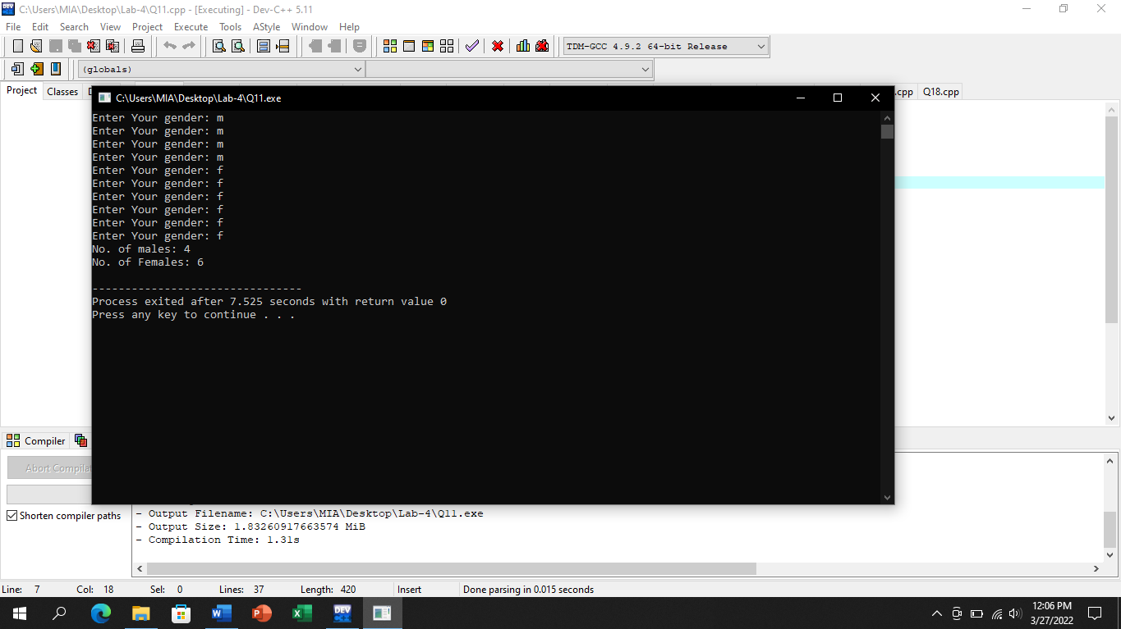

# (With for statement)

## Input:

#include<iostream>

using namespace std;

int main()

{

int i,male,female;

char gender;

male=0;

female=0;

i=1;

for(i=1,male=0,female=0;i<=10;i++)

{

cout<<"Enter Your gender: ";

cin>>gender;

if(gender=='M'||gender=='m')

male=male+1;

if(gender=='F'||gender=='f')

female=female+1;

}

cout<<"No. of males: "<<male<<endl;

cout<<"No. of Females: "<<female<<endl;

return 0;

}

## Output:

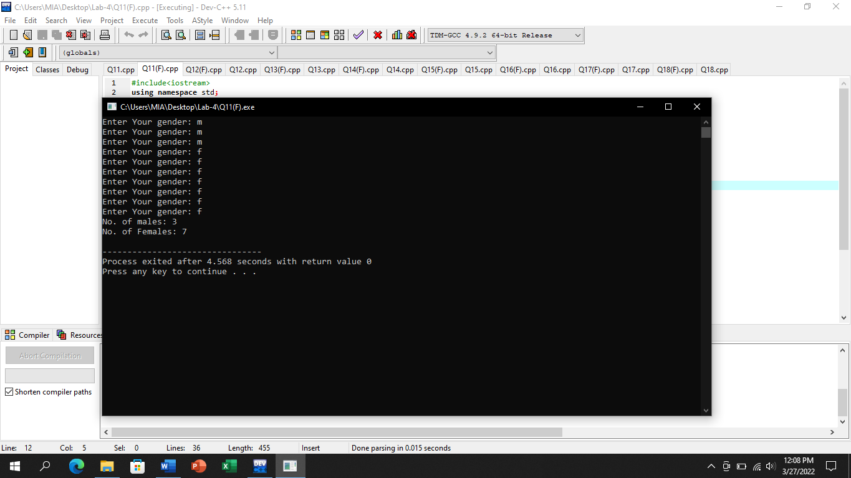

# Question No.12

## Input:

#include<iostream>

using namespace std;

int main()

{

int i,base,power,result;

cout<<"Input the base: ";

cin>>base;

cout<<"Input the power: ";

cin>>power;

i=1;

while(i<=power)

{

result=base*base;

i++;

}

cout<<"Result is: "<<result;

return 0;

}

## Output:

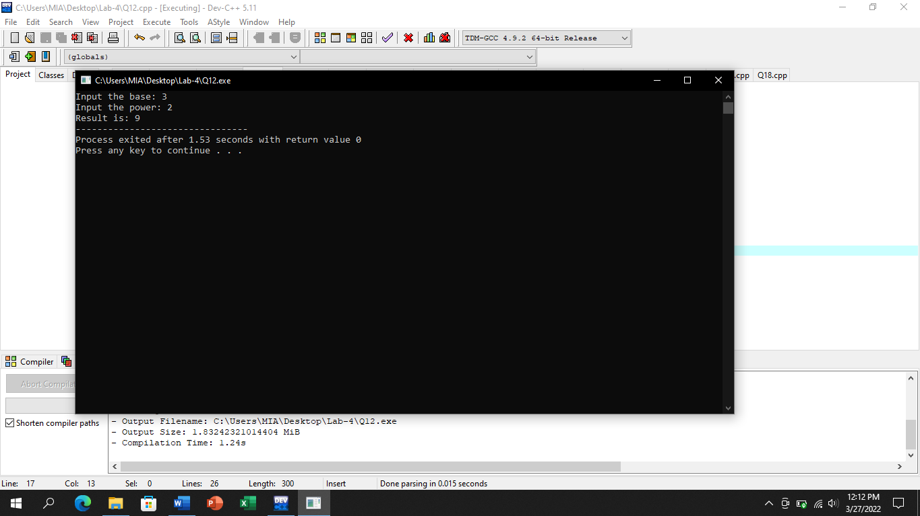

# (With for statement)

## Input:

#include<iostream>

using namespace std;

int main()

{

int i,base,power,result;

cout<<"Input the base: ";

cin>>base;

cout<<"Input the power: ";

cin>>power;

for(i=1,base,power,result;i<=power;i++)

{

result=base*base;

}

cout<<"Result is: "<<result;

return 0;

}

## Output:

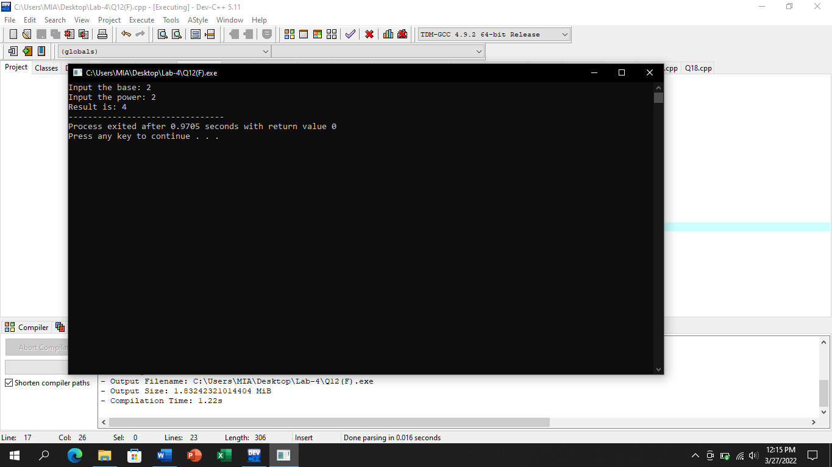

# Question No.13

## Input:

#include<iostream>

using namespace std;

int main()

{

int i,fact;

fact=1;

i=1;

while(i<=10)

{

fact=fact*i;

i++;

}

cout<<"Factorial of 10 is "<<fact;

return 0;

}

## Output:

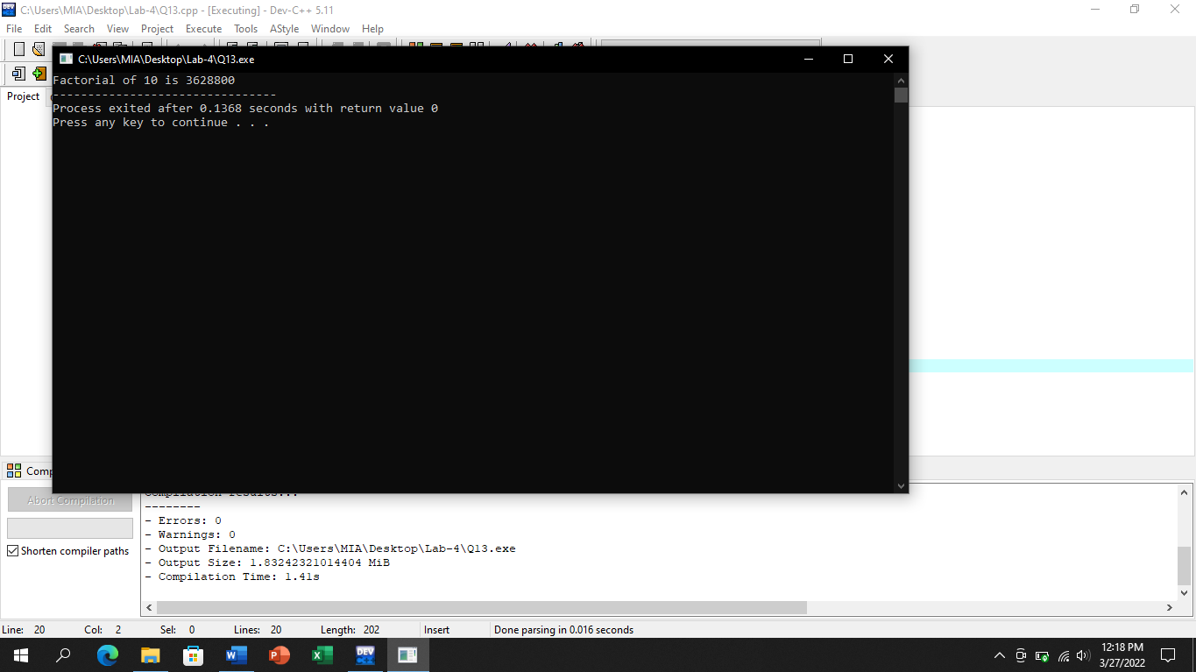

# (With for statement)

## Input:

#include<iostream>

using namespace std;

int main()

{

int i,fact;

for(i=1,fact=1;i<=10;i++)

{

fact=fact*i;

}

cout<<"Factorial of 10 is "<<fact;

return 0;

}

## Output:

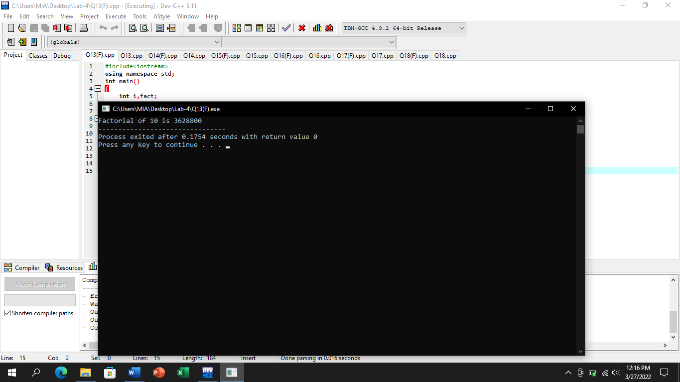

# Question No.14

## Input:

#include<iostream>

using namespace std;

int main()

{

int i,fact,num;

cout<<"Enter a number: ";

cin>>num;

fact=1;

i=1;

while(i<=num)

{

fact=fact*i;

i++;

}

cout<<"Factorial of given number is: "<<fact;

return 0;

}

## Output:

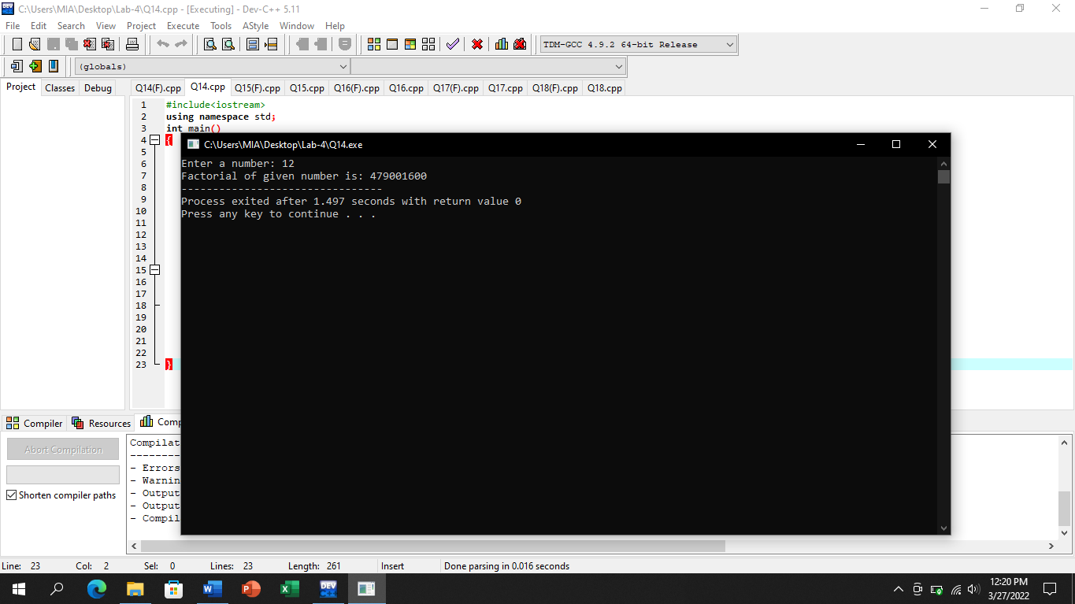

# (With for statement)

## Input:

#include<iostream>

using namespace std;

int main()

{

int i,fact,num;

cout<<"Enter a number: ";

cin>>num;

for(i=1,fact=1;i<=num;i++)

{

fact=fact*i;

}

cout<<"Factorial of given number is: "<<fact;

return 0;

}

## Output:

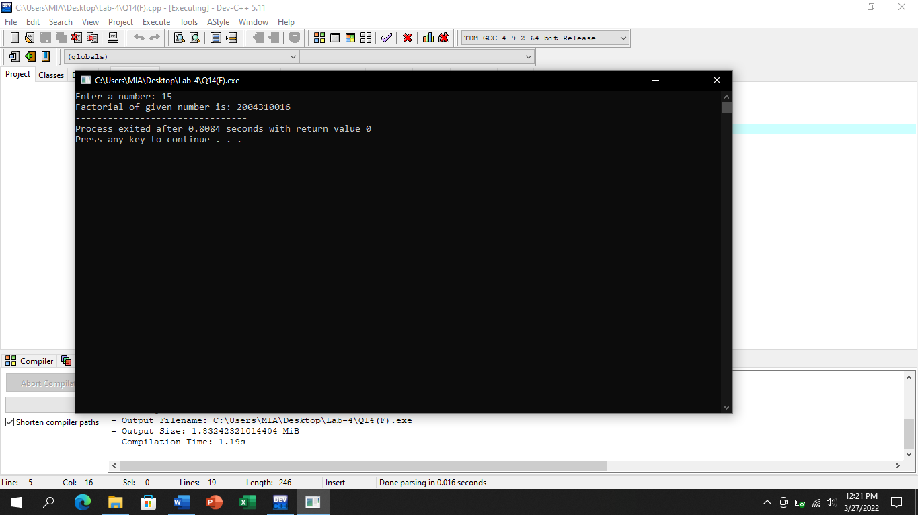

# Question No.15

## Input:

#include<iostream>

using namespace std;

int main()

{

int i,num;

num=9;

i=1;

while(i<=10)

{

cout<<"9 X "<<i<<" = "<<9*i<<endl;

i++;

}

return 0;

}

## Output:

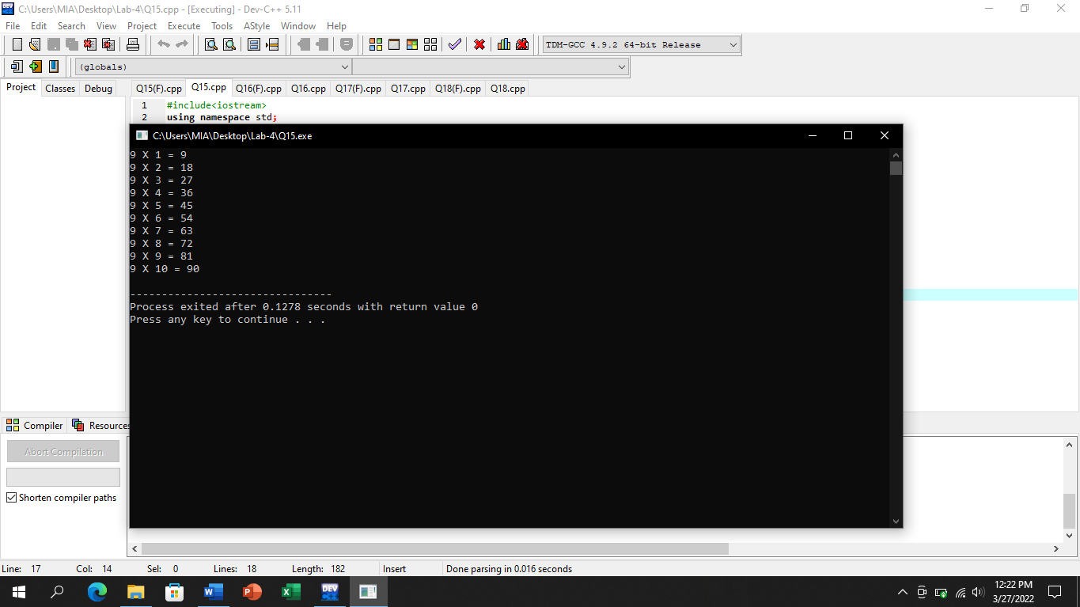

# (With for statement)

## Input:

#include<iostream>

using namespace std;

int main()

{

int i,num;

for(i=1,num=9;i<=10;i++)

{

cout<<"9 X "<<i<<" = "<<9*i<<endl;

}

return 0;

}

## Output:

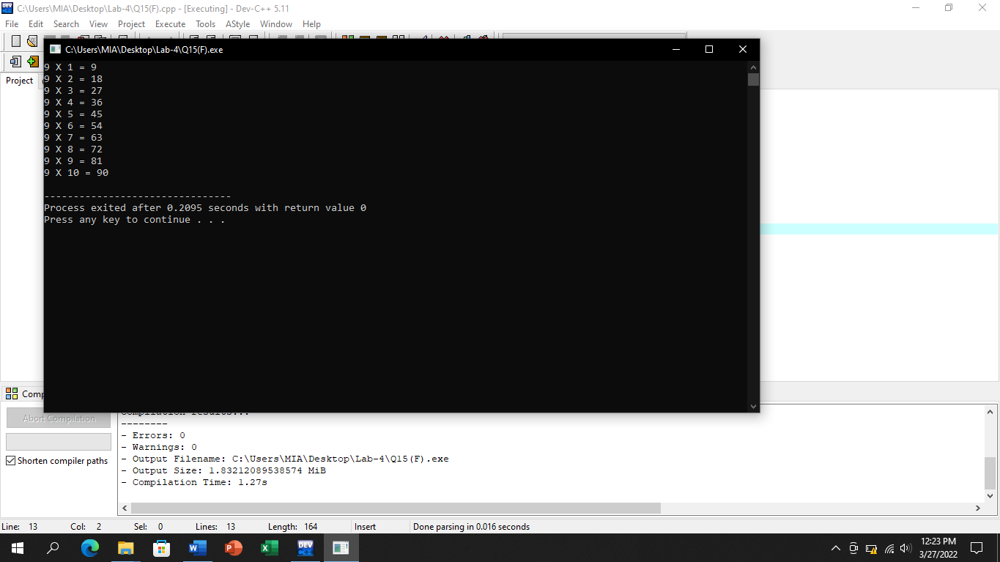

# Question No.16

## Input:

#include<iostream>

using namespace std;

int main()

{

int i,num;

cout<<"Enter the number ";

cin>>num;

i=1;

while(i<=10)

{

cout<<num<<" X "<<i<<" = "<<num*i<<endl;

i++;

}

return 0;

}

## Output:

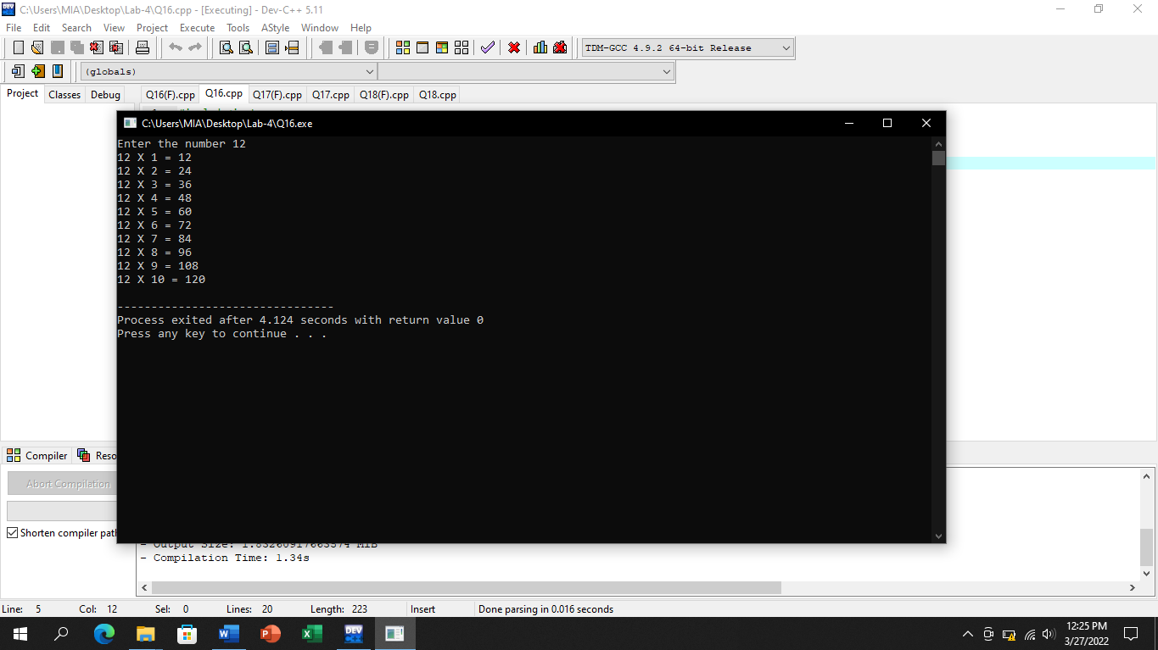

# (With for statement)

## Input:

#include<iostream>

using namespace std;

int main()

{

int i,num;

cout<<"Enter the number ";

cin>>num;

for(i=1;i<=10;i++)

{

cout<<num<<" X "<<i<<" = "<<num*i<<endl;

}

return 0;

}

## Output:

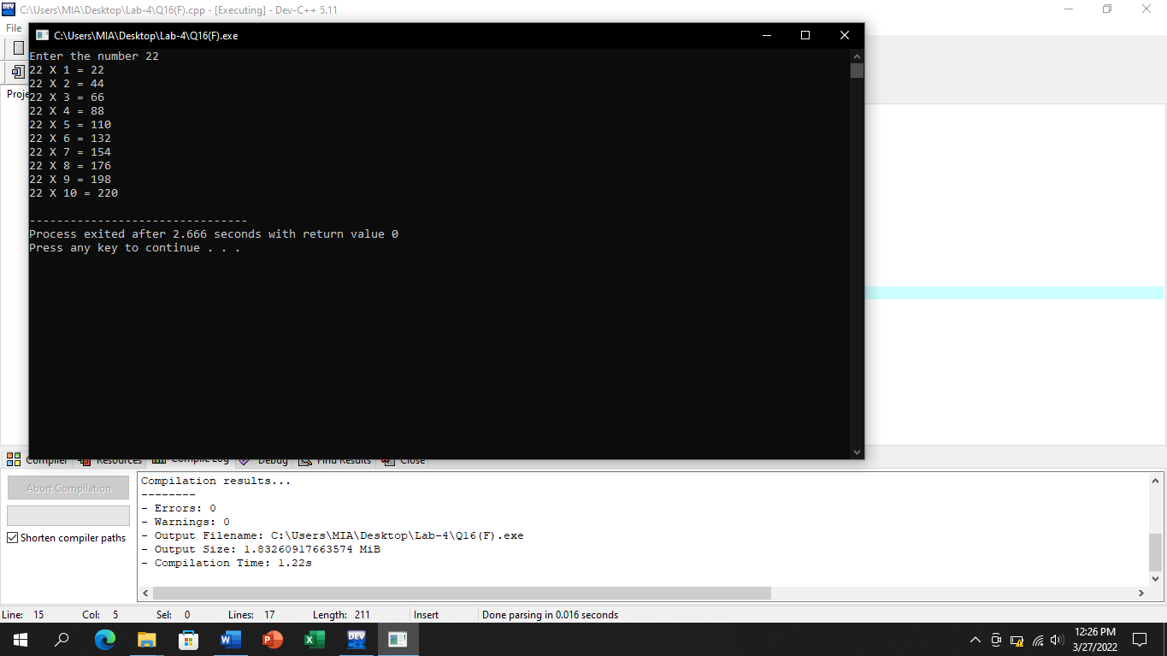

# Question No.17

## Input:

#include<iostream>

using namespace std;

int main()

{

int i,num;

cout<<"Enter a five digit number: ";

cin>>num;

i=1;

while(i<=5)

{

cout<<num%10;

num=num/10;

i++;

}

return 0;

}

## Output:

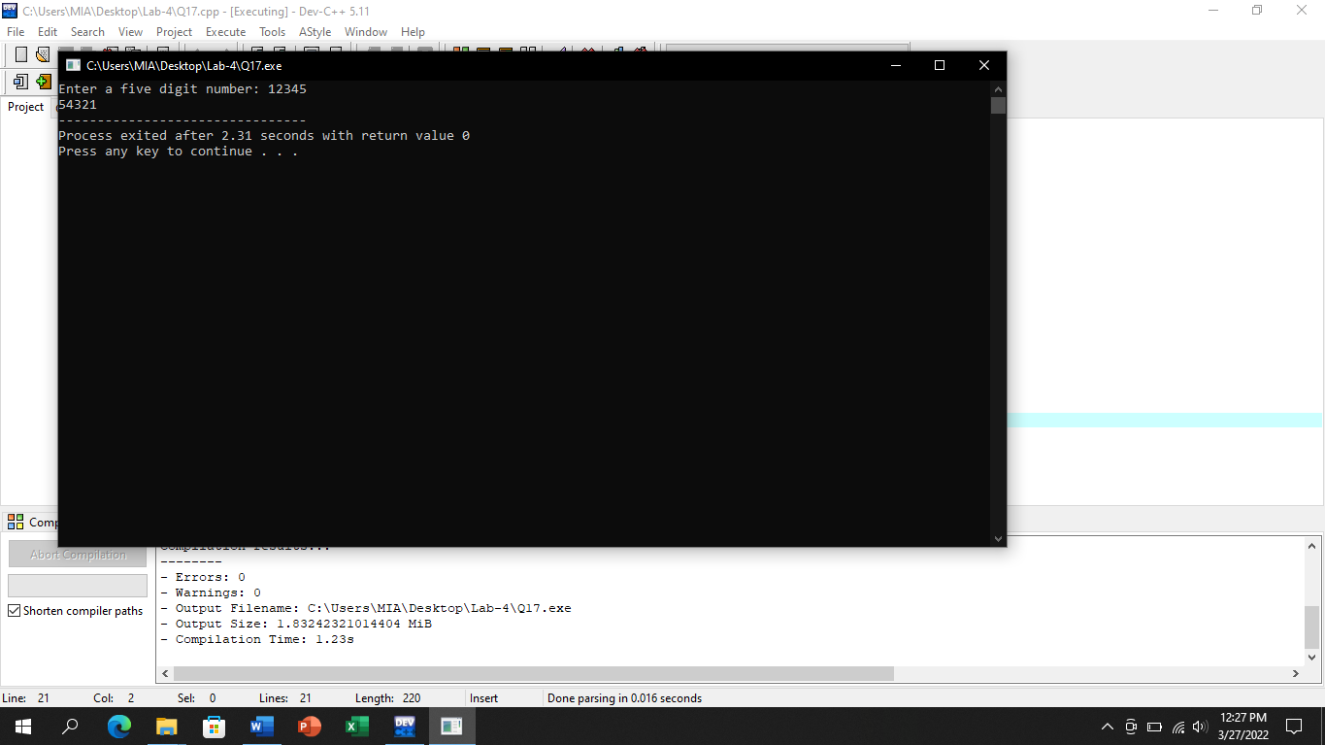

# (With for statement)

## Input:

#include<iostream>

using namespace std;

int main()

{

int i,num;

cout<<"Enter a five digit number: ";

cin>>num;

cout<<"The reverse number is: ";

for(i=1;i<=5;i++)

{

cout<<num%10;

num=num/10;

}

return 0;

}

## Output:

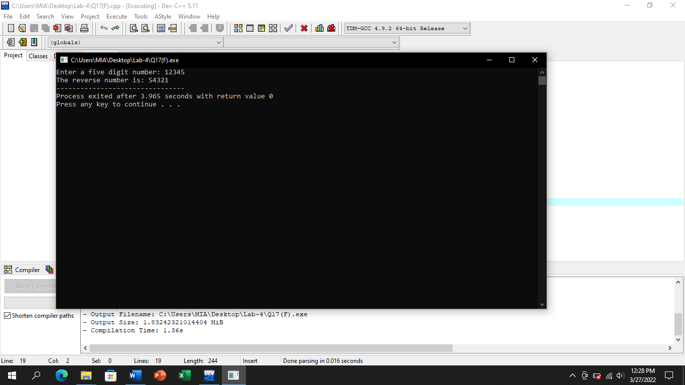

# Question No.18

## Input:

#include<iostream>

using namespace std;

int main()

{

int i,num,large,small;

large=0;

small=99999;

i=1;

while(i<=10)

{

cout<<"Enter a number: ";

cin>>num;

if(num>large)

{

large=num;

}

if(num<small)

{

small=num;

}

i++;

}

cout<<"The largest number is: "<<large<<endl;

cout<<"The smallest number is: "<<small;

return 0;

}

## Output:

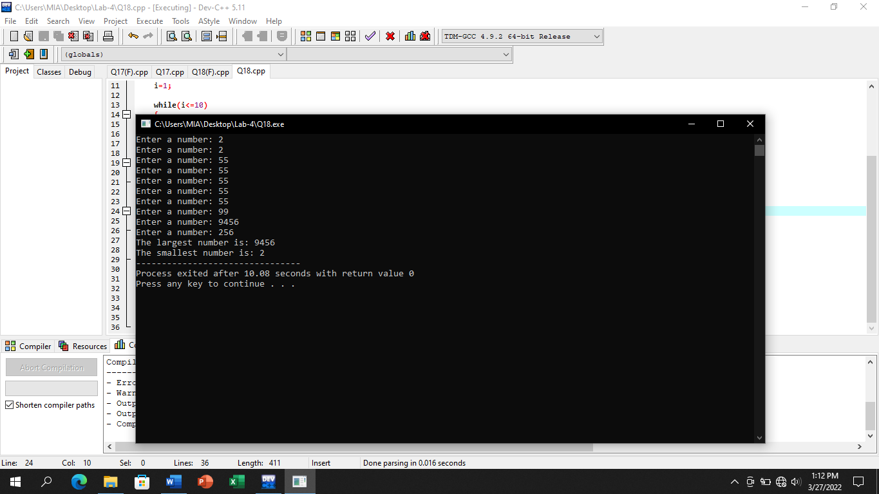

# (With for statement)

## Input:

#include<iostream>

using namespace std;

int main()

{

int i,num,large,small;

for(i=1,large=0,small=99999;i<=10;i++)

{

cout<<"Enter a number: ";

cin>>num;

if(num>large)

{

large=num;

}

if(num<small)

{

small=num;

}

}

cout<<"The largest number is: "<<large<<endl;

cout<<"The smallest number is: "<<small;

return 0;

}

## Output:

